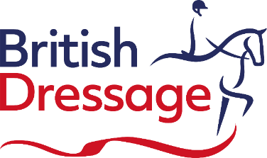

APPLICATION FORM FOR DISPENSATION FOR JOINED REINS

Requests must be submitted to the British Dressage natasha.pearce@britishdressage.co.uk

Dispensation from British Dressage rules will be given to members with an impairment for a proven functional need according to rule 25 in the British Dressage Members Handbook 2023.

To ensure prompt attention please ensure that all paperwork is provided, including a copy of your most recent classification score sheet and medical diagnostic paperwork. Classification score sheets can be obtained from Felicity Towers at the BEF. Felicity.towers@bef.co.uk

Athlete details:

Name:
Tel:
Email address:
BD Membership number
Please state your Para Classification Grade and status: | State Grade:
 | Is this a National or International Classification?
State the level at which you will be competing:
Medical Diagnosis:
This must be supported by independent diagnostic information from a medical professional
Dispensation request details
Dispensations for joined reins will only be approved for athletes that have a formal classification either through the FEI or Nationally and evidence must be provided of missing digits/parts of their arms.
If approved, the dispensation will be considered permanent, and the certificate date will be open ended.

Have you been granted Dispensation previously? | Yes | No
State detailed reasons why you are claiming dispensation benefits for joined reins
Additional comments

Upon receipt of this information, it will be considered by our Dispensation Panel and your certificate will follow within 3 weeks. To ensure prompt attention please ensure that all paperwork is provided.

Mandatory attachments:
- Copy of full score sheet from most recent classification
- Medical documentation from a GMC registered Medical Practitioner or Chartered Physiotherapist
- Any other supporting material.
Date: | Athlete’s signature:

