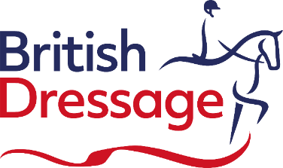

APPLICATION FORM FOR DISPENSATION

Requests must be submitted to the British Dressage natasha.pearce@britishdressage.co.uk

Dispensation from British Dressage rules will be given to members with an impairment for a proven functional need according to rule 25 in the British Dressage Members Handbook 2023.

To ensure prompt attention please ensure that all paperwork is provided, including a copy of your most recent classification score sheet (if you are classified as a para rider) and or medical diagnostic paperwork. Classification score sheets can be obtained from Felicity Towers at the BEF. Felicity.towers@bef.co.uk

Athlete details:

Name:
Tel:
Email address:
BD Member (please tick): |  | Yes | No | If yes, BD member no:
Do you have a Para Classification Grade (please tick)? | Yes |  | No | If yes, state Grade:
 | If yes, state if it is a National or International Grade:
State the level you will be competing at:
Medical Diagnosis:

Dispensation request details

Dispensation certificates required to be renewed periodically which will be stated on your Dispensation Certificate, unless the condition is deemed to be permanent. The dispensation will then be open-ended.
There are specific Compensating Aids are issued for a given period.

Have you been granted Dispensation previously? | Yes | No
List the Compensating Aids being requested based on your functional needs
State detailed reasons why you are claiming dispensation benefits
Additional comments

Upon receipt of this information, it will be considered by our Dispensation Panel and your certificate will follow within 3 weeks. To ensure prompt attention please ensure that all paperwork is provided.

Mandatory attachments:
- Copy of full score sheet from most recent classification (if you are classified as a para rider)
- Medical documentation from a GMC registered Medical Practitioner or Chartered Physiotherapist
- Any other supporting material.
Date: | Athlete’s signature:

